Study this webpage carefully and then answer questions 21 to 28. (8 marks)

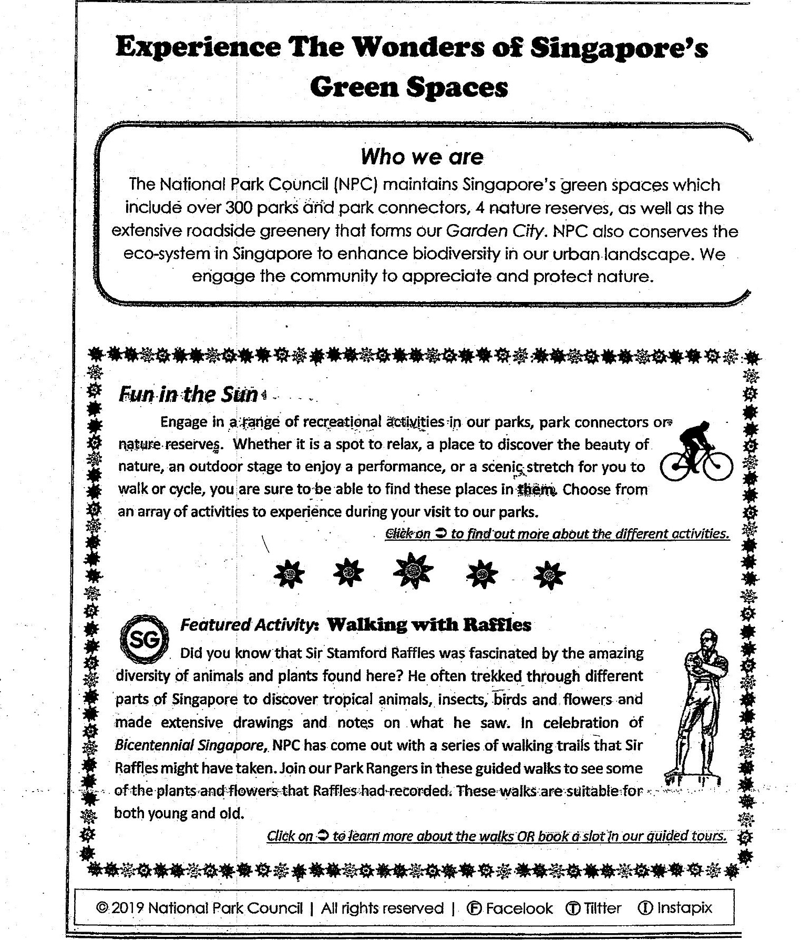

Green Spaces